**ME-512**

**Robot Manipulators: Kinematics, Dynamics and Control**

**ASSIGNMENT - 2**

**Course Instructor: Submitted by:**

**Dr. Ekta Singla Advait Chandorkar (2021MEB1264)**

**Shubha Tanaya (2021MEB1325)**

**Devanshi Sawhney (2021MEB1281)**

**Tanishq Jain (2021MEB1330)**

**SELECTED ROBOTIC MANIPULATOR**

**MTAB ARISTO**

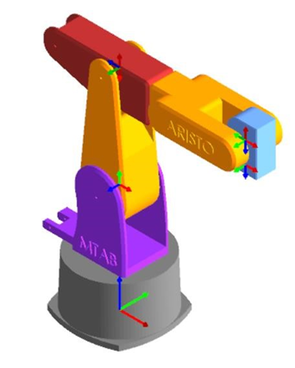 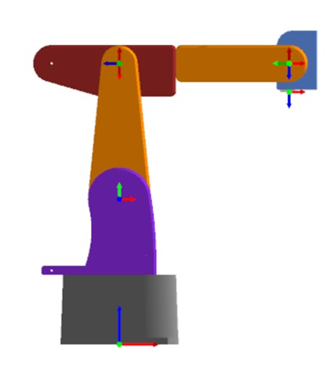

**Isometric view of Robot Front view of Robot**

**SOLUTION 1:**

1. Perform forward and inverse kinematics of MTAB Aristo using Robo-analyzer software.

a) Obtain position and orientation of the end-effector for any values of joint parameters.

b) Feed these as input to inverse kinematics and check if one of the multiple solutions matches with the joint parameters given by you in part ‘a’.

1. The value of Joint Parameters is changed to get a specific position and orientation of the end effector using Forward Kinematics.

DH PARAMETERS:

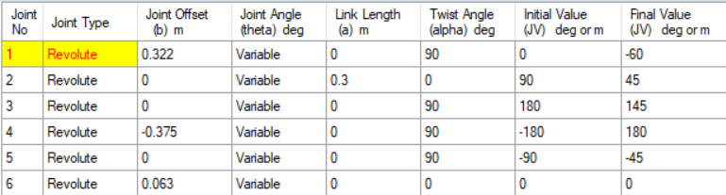

Through FORWARD KINEMATICS the end effector configuration is calculated corresponding to the entered joint parameters.

END EFFECTOR CONFIGURATION:

TRANSFORMATION MATRIX INCLUDING ORIENTATION MATRIX AND POSITION VECTOR

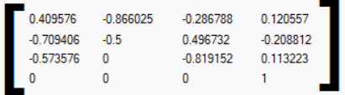

Trajectory of the robot for the specified joint parameters, stopping at the corresponding end effector position.

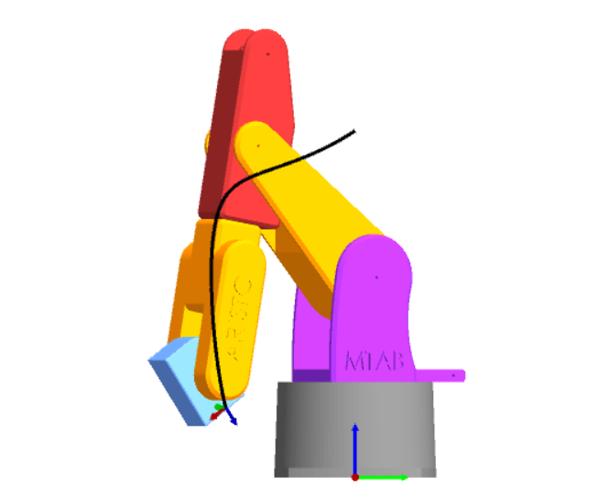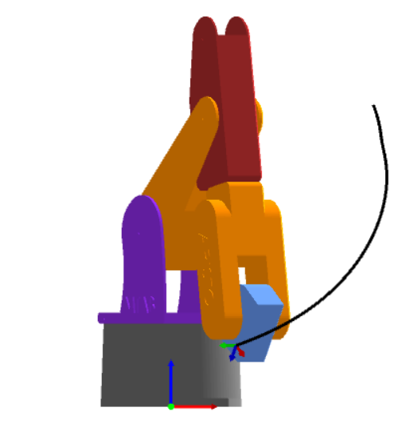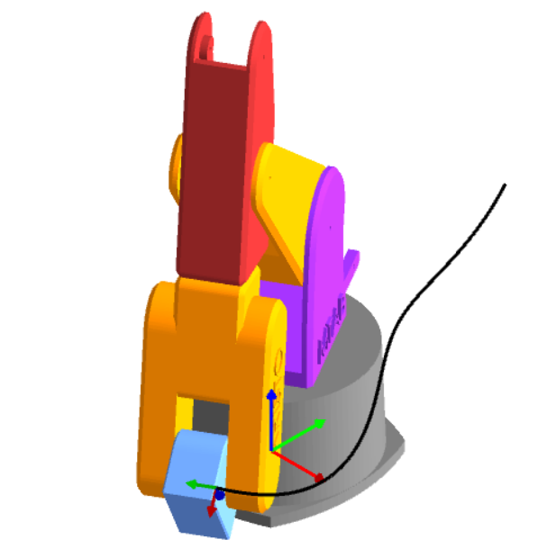

RIGHT VIEW FRONT VIEW ISOMETRIC VIEW

1. The end effector orientation matrix and position vector is entered to find the joint parameters, using Inverse Kinematics.one of the multiple solutions matches with the joint parameters given by us in part ‘a’

INPUT FOR INVERSE KINEMATICS

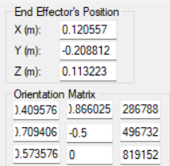

ONE OF THE SOLUTION OF INVERSE KINEMATICS MATCHES WITH THE ENTERED VALUES OF JOINT PARAMETERS.

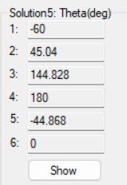

**SOLUTION 2:**

a) Taking any 2 points in Cartesian space as start and end points, solve them for inverse kinematics and using these solutions, generate a trajectory with forward kinematics.

b) Generate the plots of the joint angles and joint torques for the trajectory for no load condition. Are there any observations from ‘a’ and ‘b’?

P1= ( 0.4, 0.2, 0.6)

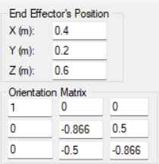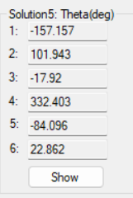

P2= ( 0.3, 0.1, 0.5)

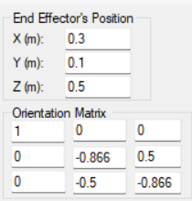 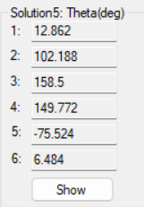

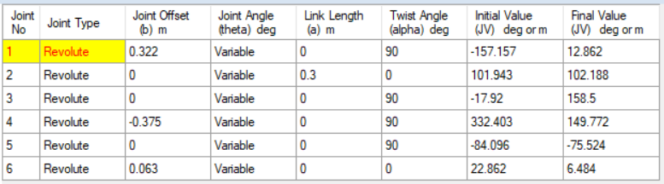

**Path Trajectory:** 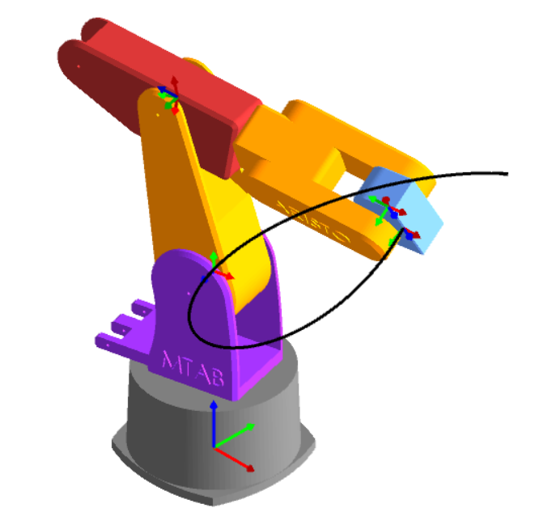

ISOMETRIC VIEW

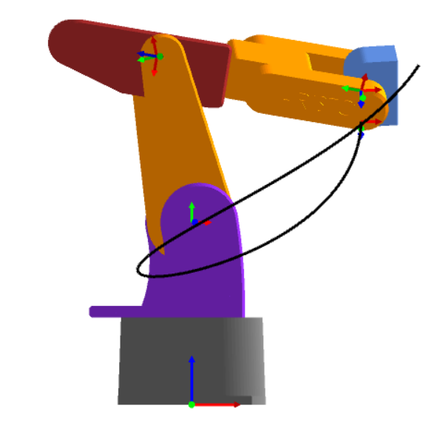

FRONT VIEW

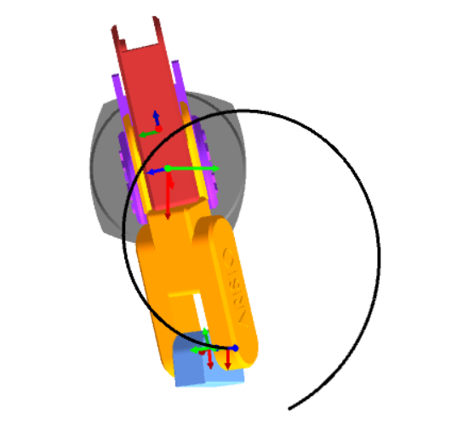

TOP VIEW

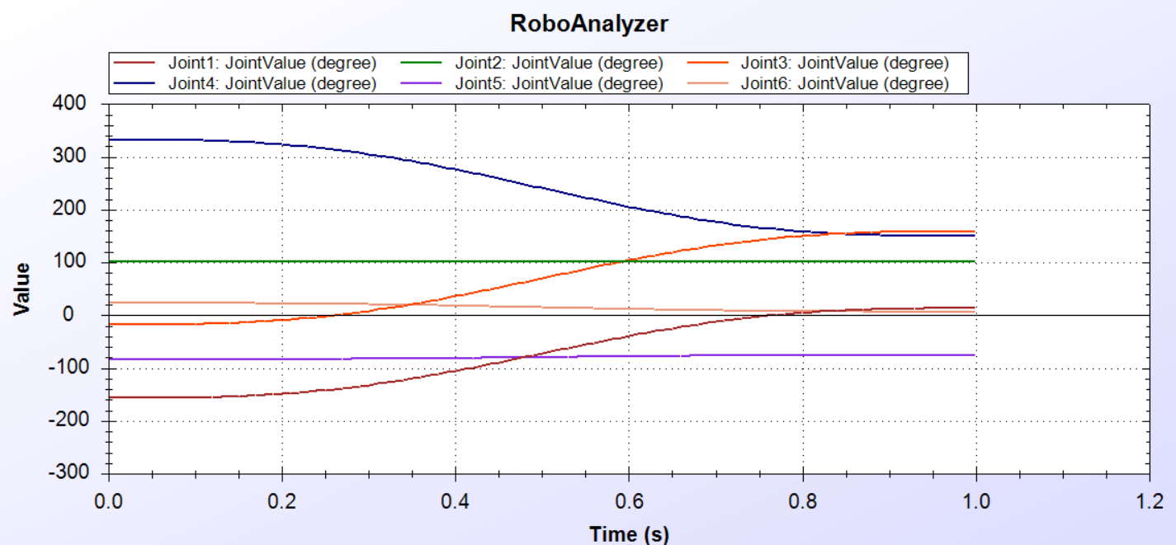

**PLOT OF JOINT ANGLES**

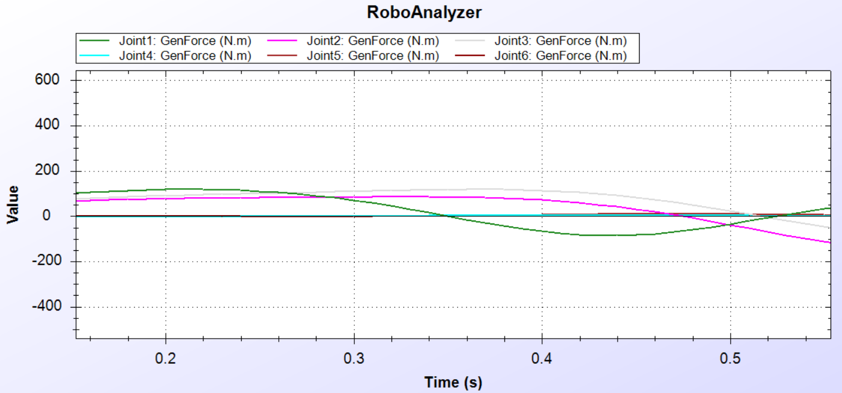

**PLOT OF JOINT TORQUES**

**Observations:**

1. By selecting different solutions (joint parameters) obtained from inverse kinematics, various path trajectories can be obtained for the same initial and final points.

2. Plots of joint angles and joint torques also vary as per the chosen joint parameters.

3. Torque at joint 2 shows the maximum variation as it’s the major joint taking the load.

Also the torque at joint 3 has similar traits as of joint 2.

**SOLUTION 3:**

**Workspace of the ARISTO Manipulator**

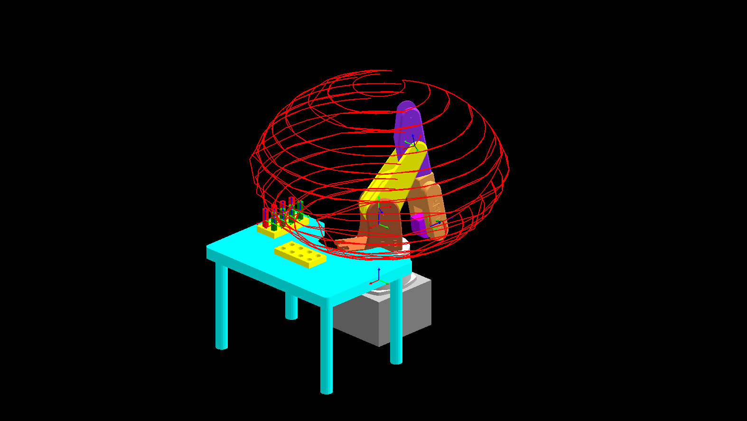

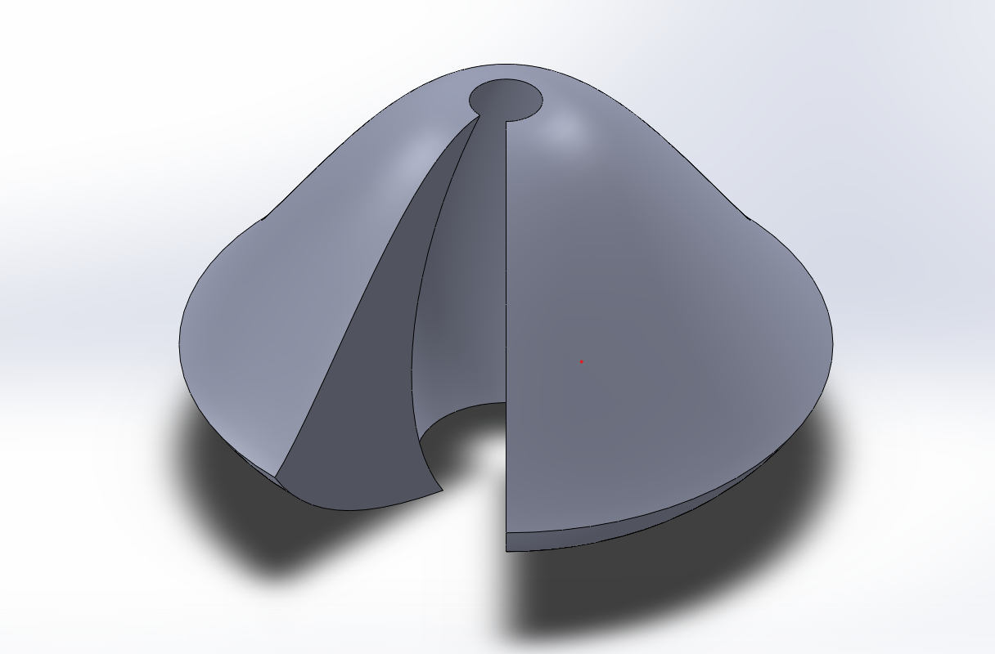

We produced the workspace of MTAB Aristo using Roboanalyzer by changing the values of final joint variables keeping in mind the angle constraints of all the 6 revolute joints of the robot. 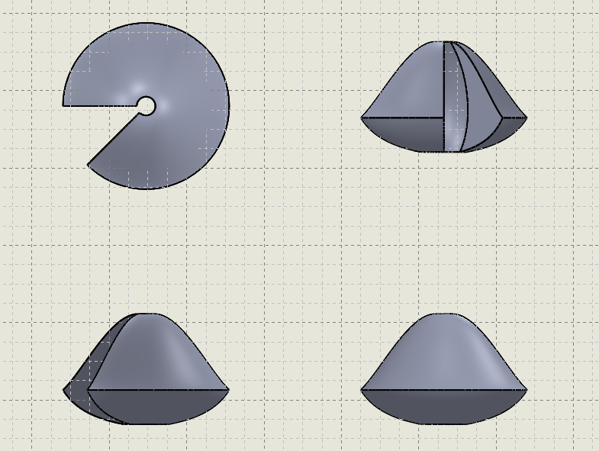

The workspace boundary of a robotic arm refers to the physical space that the arm can reach and operate within. It is determined by the length and configuration of the arm's links, the range of motion of its joints, and any physical obstacles or constraints that may be present in the environment.

In general, the workspace boundary of a robotic arm can be visualized as a three-dimensional region of space. The shape and size of this region will depend on the specific design and capabilities of the robot, as well as any limitations imposed by the task it is intended to perform.

It is important to accurately define the workspace boundary of a robotic arm in order to ensure that it can perform its intended tasks effectively and safely. This may involve modeling the arm's range of motion using mathematical algorithms or simulations, and conducting tests or experiments to verify the arm's performance within its designated workspace.

At the workspace boundary, the likelihood of encountering singularity increases as the robot's range of motion is constrained and its joints reach their maximum or minimum limits. This can make it difficult for the robot to move smoothly and accurately, which can lead to errors or unexpected behavior.

Singularity in robotics refers to a point in the robot's workspace where its motion becomes highly unpredictable or even impossible due to a loss of degrees of freedom. Singularity can occur in a robotic arm when two or more joints reach a configuration that causes the arm to lose a degree of freedom, such as when two links are aligned or parallel to each other.